***Tom Ford***

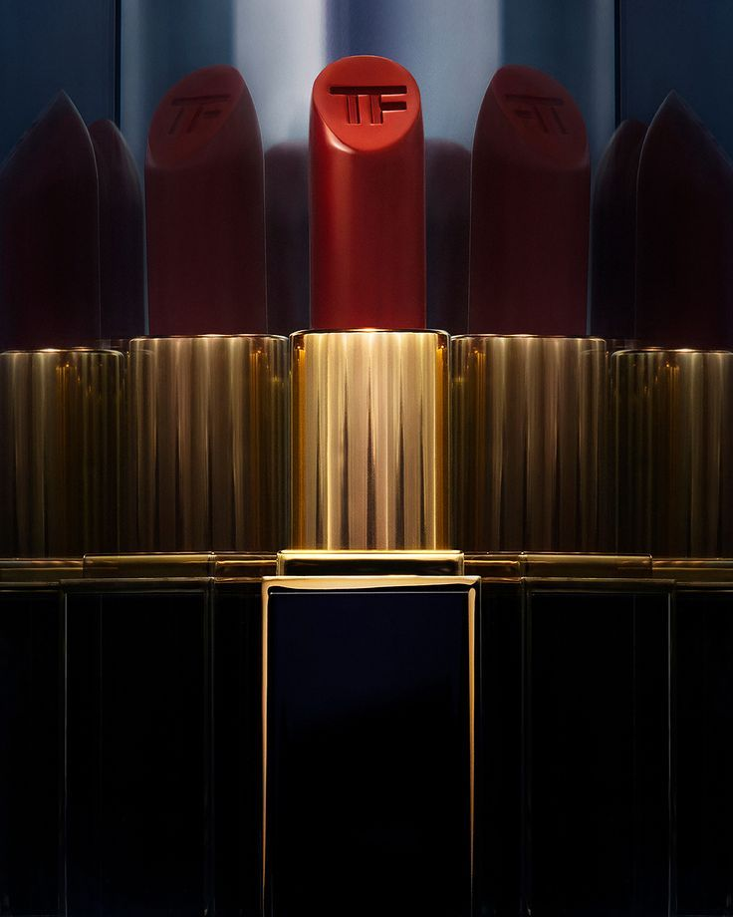

*Tom Ford has only been released for a while, but has created a worldwide fever.i Son Tomford has a long-lasting lipstick, a very classy design and especially the lead content in the lipstick is not present. Along with that is an extremely diverse color palette Son Tomford is a special and extremely luxurious gift that every modern woman aspires to have*